**Technical Memorandum**

To: Wasatch Front Central Corridor Study Management Team

From: Wasatch Front Central Corridor Study (WFCCS) Technical Team

Date: April 2017

Subject: WFCC UPDATES TO THE WASATCH FRONT TRAVEL MODEL

# Reliability Lanes

Scenarios in the WFCCS study included evaluating reversible lanes and managed lanes on arterials as part of the solution set. Managed lanes on arterials were defined as lanes where priority is given for High-Occupancy Vehicles (HOV) and for drive-alone vehicles willing to pay a toll. The previous version of the travel model estimates travel on high-occupancy toll (HOT) lanes for freeways, but not arterials. It also does not include a method for evaluating reversible lanes.

The travel model was modified so that managed lanes on arterials and reversible lanes could be evaluated for this study. Modifications were made to the following sections of the model:

* Input Master Highway Network.
* 1ControlCenter.block.
* Network processing script.
* Distribution script.
* Mode choice script.
* Final assignment script.

Changes made to the travel model to incorporate reliability lane calculations—specifically relating to network processing—require the model to use Cube version 6.4.1 or later.

## Methodology

### Master Highway Network

A new field set was added to the model’s master highway network links. There is no set naming convention required by the model for these fields; the fields can be named in a way that makes sense for the scenario and as the user deems appropriate. However, at least one reliability lane field must exist on the master network. If reliability lane functionality is not part of the scenario, then the values for this field should be set to zero. General purpose lanes that are contained within scenarios that have reliability lanes would still be set to a value of zero in this field. A nonzero value in the reliability lane field initiates the reliability lane calculations for that link in the model.

Acceptable values that can be coded into the reliability lane fields are as follows:

* **1 to 9**: Indicates the number of managed lanes added to arterial; these lanes will be added for all time periods.
* **11 to 19**: First digit indicates that a managed lane is to be added in the peak direction with a corresponding lane reduction in the off-peak direction (i.e., reversible lane); second digit indicates the number of managed lanes added to arterial in peak direction (no lanes are added in off-peak direction).
* **21 to 29**: First digit indicates managed lane has grade separation at major intersections; second digit indicates the number of managed lanes added to arterial for all time periods.

For WFCCS, the following reliability lane fields were added to the master network:

* REL_50_S0.
* REL_50_S1.
* REL_50_S2.
* REL_50_S3.

The base 2050 scenario represented by the first field, REL_50_S0, does not include managed arterials or reversible lanes and values for all links in this field were set to zero. This field was also used for the MPO RTP scenarios since these scenarios also did not include managed arterials or reversible lanes.

### Control Center Block File

A new key variable, REL_LN, was added to the link attribute section of the “1ControlCenter.block” file. The user sets this field to the name of the reliability lane field in the master highway network corresponding to the intended scenario, as shown in Figure 38.

#### Figure 38: Setting Reliability Lane Field in Control Center

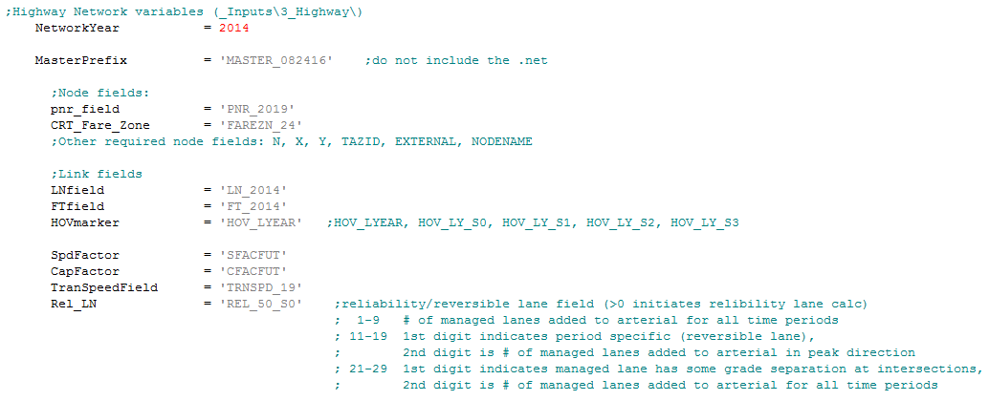

### General Parameters

The model space was separated into three travel sheds to determine peak and off-peak directions used in the reversible lane calculations:

* Ogden Travel Shed.
* Salt Lake Travel Shed.
* Provo Travel Shed.

Each travel shed is identified by a horizontal line representing the threshold between the different travel sheds. A center point of each travel shed was then identified for determining the inbound or outbound directional sense of the links:

* Center of Ogden Travel Shed: 24th Street and Washington Avenue.
* Center of Salt Lake Travel Shed: West Temple and South Temple.
* Center of Provo Travel Shed: University Parkway and University Avenue.

Figure 39 shows the variables added to the “0GeneralParameters.block” file for identifying travel sheds and inbound/outbound direction.

#### Figure 39: Variables for Establishing Travel Sheds and Inbound/Outbound Direction

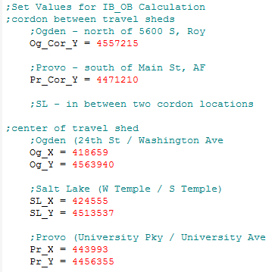

### Network Processor Script Edits

To The highway network processing script (“0_InputProcessing\c_NetworkProcessing\1_NetProcessor.s”) was modified to include the following link variables:

* **ANGLE**: Stores the angle of a highway link in degrees using the start of the link and true north as a reference (angle uses a counter-clockwise orientation).
* **DIRECTION**: Stores the direction of a link: NB, WB, SB or EB:
  + NB: <=45 degrees and >315 degrees.
  + WB: >45 degrees and <=135 degrees.
  + SB: >135 degrees and <=225 degrees.
  + EB: >225 degrees and <=315 degrees.
* **IB_OB**: Stores the directional sense of the link relative to the travel shed center point:
  + IB: Inbound.
  + OB: Outbound.
* **PkDirPrd**: Stores the time period of the peak direction:
  + 1: Peak direction is inbound in AM period.
  + 3: Peak direction is outbound in PM period.
* **Rel_Ln**: Stores the value of the reliability lane field from the scenario field in the master network.

The AdHOVCap1H link variable was also modified in the network processing script. This variable already exists and is used in the distribution model to determine the extra capacity on a link due to the presence of a HOV/HOT lane on freeways. The script was modified to expand the calculation to include arterials and freeways based on the code shown in Figure 40.

#### Figure 40: Calculating Arterial Managed Lane Capacity for the Distribution Model Code

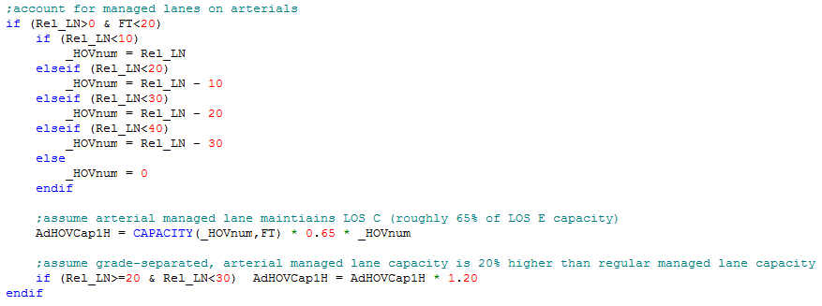

The arterial managed lane, one-hour capacity is determined by multiplying 65% of the normal capacity of the arterial link by the number of managed lanes. (This does not change the value of the link’s capacity field, Cap1hr1ln, calculated earlier in the script.) The model assumes that the HOV/HOT lane will be managed to a LOS C or higher, which has been roughly set for the travel model at 65% of the regular capacity. For arterial managed lanes with select grade-separated intersections, the model assumes the facility receives a 20% increase in capacity and free flow speed.

### Distribution Script Edits

The distribution model adds the managed lane capacity in the “4pd_mainbody_distribution.block” file. The model calculates the extra capacity by multiplying the one-hour capacity calculated in the network processing script by the number of hours in each period and stores these into link-working variables. The model then evaluates if the managed lane is reversible (i.e., Rel_Ln=11-19). If the link contains a reversible lane, then the managed lane capacity is added in the peak direction only (inbound peak directions are AM and EV periods, outbound peak directions are MD and PM periods). If the reversible lane is on a freeway, then off-peak direction links are excluded from the path choice. Figure 41 shows the code block containing the capacity edits.

#### Figure 41: Adding Managed Lane Capacity in the Distribution Model Code

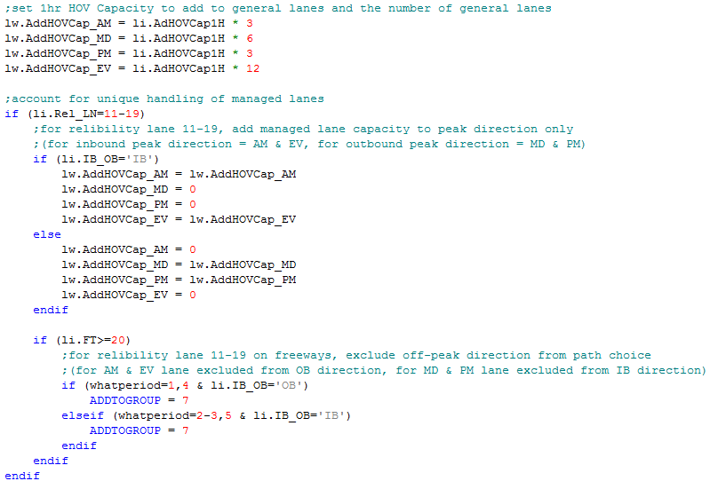

### Mode Choice Script Edits

Significant changes were made to the auto skim script, “03_Skim_auto.s,” in the mode choice section of the model. The script was rewritten to expressly account for travel times on managed lane facilities. The script estimates travel times and distances between zones along different possible paths: general-purpose lanes, HOV, HOT, and toll facilities. Travel times and distances are then used later in calculating the mode of each trip.

Travel times on arterial managed lanes were set using a similar pattern to freeway managed lane travel times:

* Off-peak travel times (based on MD period) are assumed to be 98% of free flow speed.
* AM and PM peak travel times are assumed to be 85% of free flow speed (or approximately LOS C).

For reversible lanes, travel times are only considered in the peak direction. Off-peak direction travel times are set to a high value; these will not be considered viable paths in the path builder.

### Assignment Script Edits

The final assignment script was edited, like distribution and mode choice, to account for reliability lanes. The script accounts for the presence of a reliability lane by adjusting the capacity. If a link is coded as a reliability lane on an arterial, then the model increases the link’s capacity using the same method as the distribution script. For both arterials and freeways coded as reversible lanes, the model adds capacity in the peak direction only. The capacity on arterials is added only in memory. The model does not report the added capacity onto the network links.